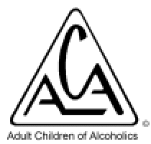

ACA-intergroup Norway has the pleasure of inviting you to a day of love, hope and fellowship. Saturday the 17th of June 2017 at Vestre Aker Menighetshus, Ullevållsveien 117, Oslo. Voluntary entrance fee 150 NOK. Coffee, cakes, dinner and literature will be sold on site. The arrangement is open to everyone including non-members, so feel free to bring friends and family.
We will focus on the 12 steps of ACA, the Solution and how we, through working with the program, recover from the consequences of growing up in an alcoholic or otherwise dysfunctional family.

Program:
11:00: Doors open
11:30 – 12:30: Topic meeting with lead share: To hit an ACA bottom
12:45 – 13:45: Speak by Majbrit ACA-Danmark: ACA-international, WSO and service
13:45 – 14:30: Lunch
14:30 – 15:30: Panel discussion: Sponsorship
15:45 – 16:45: Speak by Espen ACA-Råholt: ACA story
17:00 – 18:00: Topic meeting with lead share: The Inner child/Loving parent
18:00 – 19:30: Dinner – we will order takeaway
19:30 – 20:30: Speak by Majbrit ACA-Danmark: ACA story
20:45 – 21:30: Light meeting with topic: Gratitude
21:30 – 21:45: Countdown
22:00: Doors close

If you want to contribute with service and/or want more information, please send an email to acatreff@gmail.com. See also www.acanorge.org for updated information.

